**New ZTU Hybrid Capacitor series from Panasonic Industry: the evolution of endurance excellence**

AEC-Q200 compliant ZTU series sets new standards for endurance, ripple current and temperature tolerance.

Munich, APRIL 2023

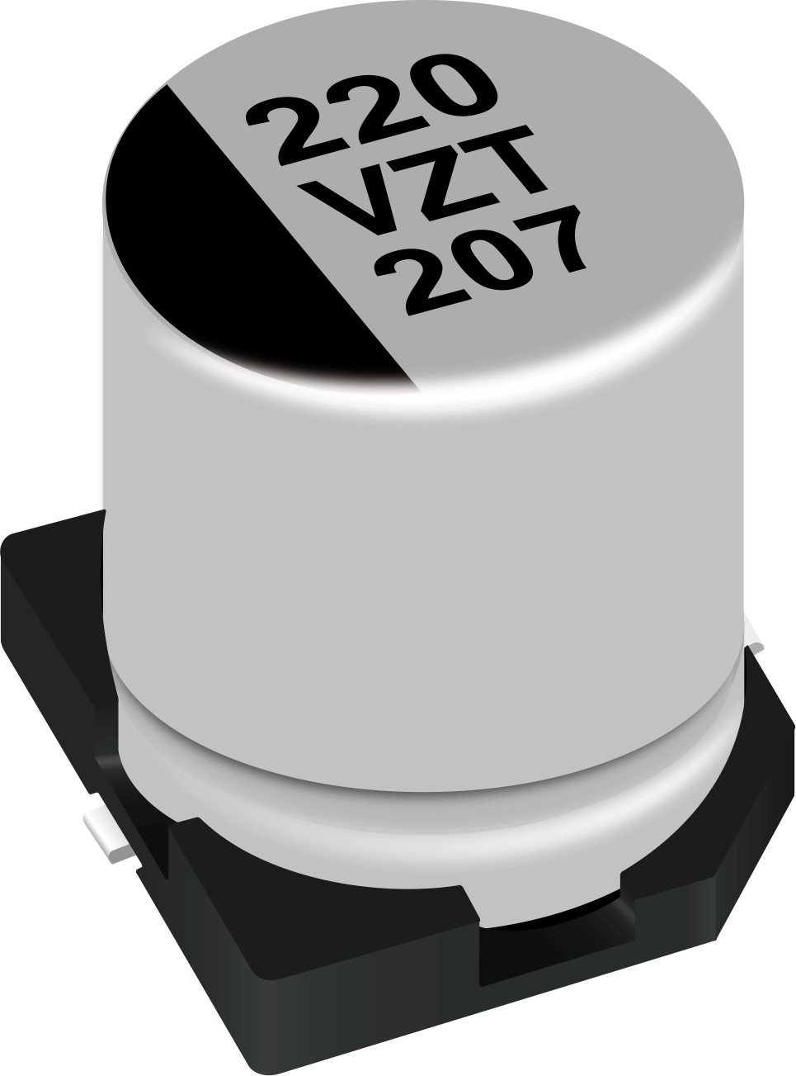Advancing the performance specifications of the popular ZT and ZC series of electrolytic Polymer Hybrid Capacitors, Panasonic Industry introduces the new AEC-Q200 qualified ZTU series, with exceptional reliability and ruggeddness for any demanding application.

“The ZTU series is setting new standards with its ripple current and capacitance specs and reliably guarantees circuit safety at one of the highest temperature ranges currently available on the market,” points out Hirofumi Maruyama from Panasonic Industry Europe.

Available with a rated voltage 25V~35VDC / 220 560 µF and a significant increase of 80% in ripple current capability in comparison to the ZC series, the ZTU has been proven for 4000 hours at 125°C & 135°C and thus would be the ideal choice where high temperature tolerance and high current capability is being demanded by the application.

This is highly relevant for a wide range of applications, as Maruyama summarizes: “As well as many others, it reliably qualifies for being applied in DC/DC or AC/DC inverters, robotics, rectifier circuits - and in particular for automotive applications where conditions turn out to be exceptionally severe”.

Speaking of tough: Panasonic Industry also offers a vibration-proof version of ZTU capacitors ~~i~~n both 8mm and 10mm diameter versions.

These are able to handle shocks of up to 30G, while the standard parts also have a vibration tolerance of 10G.

For further information on the new ZTU series capacitors, please refer to the [Panasonic Industry Product Finder](https://industry.panasonic.eu/productfinder?mode=FILTER_MODE&group=Capacitors&category=Hybrid+capacitors&lineup=Conductive+Polymer+Hybrid+Aluminum+Electrolytic+Capacitors&series=ZTU+%28High+temp.+reflow%29)**About Panasonic Industry Europe GmbH**

Panasonic Industry Europe GmbH is part of the global Panasonic Industry organization, one of the five major operating companies within Panasonic Holding. Panasonic Industry Europe provides products and services for industrial customers all over Europe.  
  
Panasonic Industry Europe is committed to enabling customers achieve their goals in a broad range of industrial sectors such as mobility, infrastructure, automation, medical, appliances, smart living, and security. With the know-how of devices and solution technologies, cultivated through a global mindset and over a century of tradition, Panasonic Industry collaborates closely with customers to create a sustainable future.

Panasonic Industry Europe’s broad and diverse product portfolio encompasses key electronic component sectors including electromechanical and passive components, batteries and other energy products, sensors and wireless connectivity modules, thermal management materials and custom solutions, as well as automation devices & solutions.

More about Panasonic Industry Europe: [http://industry.panasonic.eu](http://industry.panasonic.eu/)

**About the Panasonic Group**

A global leader in developing innovative technologies and solutions for wide-ranging applications in the consumer electronics, housing, automotive, industry, communications, and energy sectors worldwide, the Panasonic Group switched to an operating company system on April 1, 2022 with Panasonic Holdings Corporation serving as a holding company and eight companies positioned under its umbrella. Founded in 1918, the Group is committed to enhancing the well-being of people and society and conducts its businesses based on founding principles applied to generate new value and offer sustainable solutions for today’s world. The Group reported consolidated net sales of Euro 56.40 billion (7,388.8 billion yen) for the year ended March 31, 2022. Devoted to improving the well-being of people, the Panasonic Group is united in providing superior products and services to help you Live Your Best.   
To learn more about the Panasonic Group, please visit: <https://holdings.panasonic/global/>