Panasonic Industry launches new Bluetooth® Low Energy module with 512 kB flash for cost-effective applications that still require high performance
Full-featured, multiple interfaces: With the new PAN1782, Panasonic Industry complements its series of state-of-the-art BLE modules.
Munich, SEPTEMBER 2022
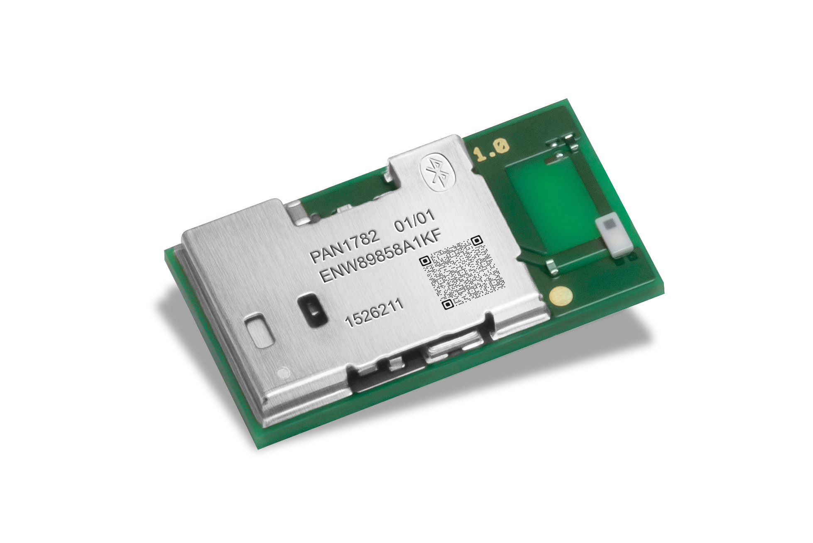
Panasonic Industry Europe has extended its range of Bluetooth® LE modules with the launch of the PAN1782, which targets cost-effective applications that still require high performance, including professional lighting, asset tracking, smart home, advanced wearables, and higher value IoT applications.

The PAN1782 is based on Nordic Semiconductor’s nRF52833 ultra-low-power multiprotocol Bluetooth 5.1 SoC and offers 512 kB flash and 128 kB RAM memory available for higher value applications. It supports Bluetooth® LE, Bluetooth® mesh, 802.15.4,Thread, Zigbee, and proprietary 2.4 GHz protocols.

Measuring just 15.6 x 8.7 x 2.0mm, the module offers a full range of interfaces including GPIO, UART, QSPI, I2C, I2S, PDM, ADC, PWM, NFC-A and USB2.0. Standby power is under 1µA, transmit and receive power is 4.8 mA at 0dBm; transmit power is +8 dBm; receive sensitivity is -95 dBm @1Mb/s,-103 dBm @125kb/s. The PAN1782 module comes with the APPROTECT HW Revision of nRF52833 which secures it from fault injections - and has a wide range of certifications, such as CE RED, FCC, ISED, KCC, MIC, RCM.

Comments Tomislav Tipura from Panasonic Industry: “Like other members of our BLE module family, the PAN1781 coming with 256kB flash and PAN1780 which features a massive 1024kB flash capacity, the PAN1782 is optimized for low power consumption without loss of performance or range. The 1.7 V to 5.5 V supply voltage range enables powering the device from rechargeable batteries or over USB.”

Learn more about the latest member of Panasonic’s module family on our web page.

About the Panasonic Group
A global leader in developing innovative technologies and solutions for wide-ranging applications in the consumer electronics, housing, automotive, industry, communications, and energy sectors worldwide, the Panasonic Group switched to an operating company system on April 1, 2022 with Panasonic Holdings Corporation serving as a holding company and eight companies positioned under its umbrella. Founded in 1918, the Group is committed to enhancing the well-being of people and society and conducts its businesses based on founding principles applied to generate new value and offer sustainable solutions for today’s world. The Group reported consolidated net sales of Euro 56.40 billion (7,388.8 billion yen) for the year ended March 31, 2022. Devoted to improving the well-being of people, the Panasonic Group is united in providing superior products and services to help you Live Your Best.
To learn more about the Panasonic Group, please visit: https://holdings.panasonic/global/

About Panasonic Industry Europe
Panasonic Industry Europe GmbH is part of the global Panasonic Group and provides automotive and industrial products and services in Europe.
The company’s portfolio covers key electronic components, devices and modules up to complete solutions and production equipment for manufacturing lines across a broad range of industries.
More about Panasonic Industry Europe: http://industry.panasonic.eu

