**Access all areas now – with Panasonic Industry’s new ultimately compact Cordless Impact Driver**

Flat motor, flat hammer mechanism and flat head greatly shorten the body length to only 98mm

Munich, October 2022

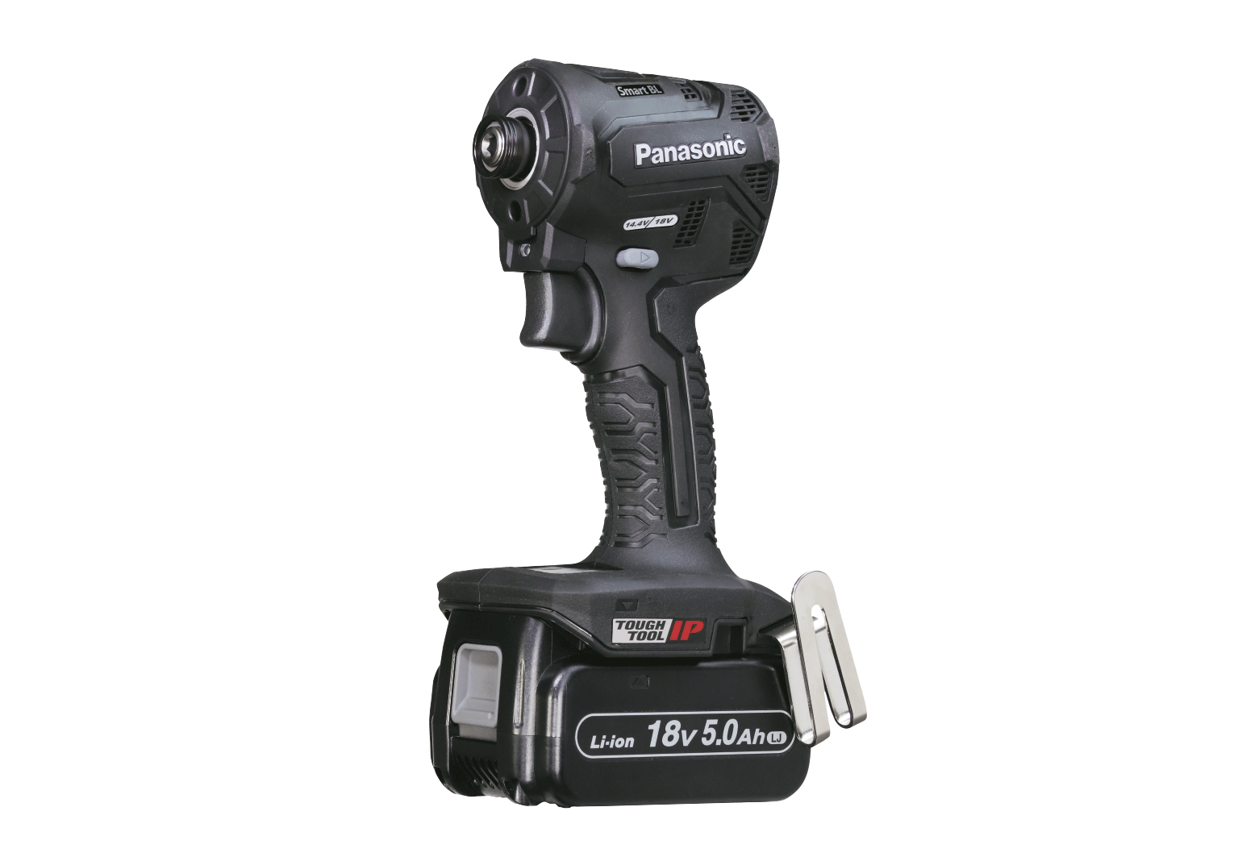Panasonic Industry Europe is launching a new highly versatile Cordless Impact Driver EY1PD1 with a very short body length of only 98mm for high power impact tightening even in narrow areas. With a low body weight of only 1.5kg the device comes with new right-angle and eccentric attachments for convenient operation in tight spots, tight corners and tight angles.

Panasonic’s new 3x ‘flat’ innovations enable the greatly shortened body length. A unique high-density compact brushless motor structure allows 30% size reduction compared to previous models while maintaining high power output with improved torque and rotation speed. The vector control technology guarantees optimal motor performance with motor speed and power being controlled in real time. The downsized hammer (50% volume reduction) and efficient shaft parts layout (20mm reduction in length) result in much shorter impacting structure.

Comments Kunihiko Nedachi, Head of Panasonic Power Tools Europe*: “Our new Cordless Impact Driver is real leading edge technology with the 3x ‘flat’ innovations enabling a very compact design and the new right-angle and eccentric attachments guaranteeing access to even the tightest areas.”*

Technical details of the EY1PD1 impact driver include a one touch bit lock system (6.35mm, 1/4", Hex), the maximum torque(18V) is 155Nm high mode, 120Nm medium mode, 40Nm low mode, maximum impacts per minute are 4100ipm high mode, 3100ipm medium mode, 2100ipm low mode.

For further information on Panasonic’s new Cordless Impact Driver please [visit the world of Panasonic Power Tools.](https://www.panasonic-powertools.eu/en/construction/products/Impact-Driver/Cordless-Impact-Driver-EY1PD1)

**About the Panasonic Group**

A global leader in developing innovative technologies and solutions for wide-ranging applications in the consumer electronics, housing, automotive, industry, communications, and energy sectors worldwide, the Panasonic Group switched to an operating company system on April 1, 2022 with Panasonic Holdings Corporation serving as a holding company and eight companies positioned under its umbrella. Founded in 1918, the Group is committed to enhancing the well-being of people and society and conducts its businesses based on founding principles applied to generate new value and offer sustainable solutions for today’s world. The Group reported consolidated net sales of Euro 56.40 billion (7,388.8 billion yen) for the year ended March 31, 2022. Devoted to improving the well-being of people, the Panasonic Group is united in providing superior products and services to help you Live Your Best.   
To learn more about the Panasonic Group, please visit: <https://holdings.panasonic/global/>